In the last lesson we covered how to draw circles on our canvas in random location but that only get us so far we only have static circles on the screen we want to make sure these things are animating so that we give the user an interesting experience something that might not be used to when they visit our site so how do we get our circles moving on the screen well instead of dealing all the circles it’s going to be easier for us to deal with just one circle and get that thing moving before we go on and moving all the circles at the same time sop lets go ahead and comment all the code we have right now just dop that we can focus on one individual circle We comment out rectangles and then we will comment out our for loop as well as shown below

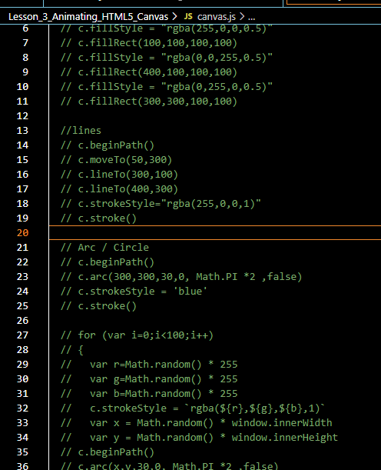

We are commenting instead of deleting it because its going to be useful for us to reference later on. Because we are going to be using the same concept Now we save our file and then it get refreshed Now it will look like below



You are going to see we have a blank canvas but now we want to actually create a circle that we can get moving and basically bouncing off the sides so our screen so as you know based on the last lesson we can create a circle using the arc method that we have right here so lets go ahead and copy the code for drawing circle in the loop as shown below

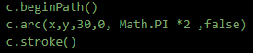

Now paste it in the bottom of the code and uncomment them

And since our arc method is using x and y variable that we set within this for loop. Let’s go ahead and give it a hard-coded value that is 200 and 200 and if we refresh the page then we are going to see that we have a circle on our screen as shown below

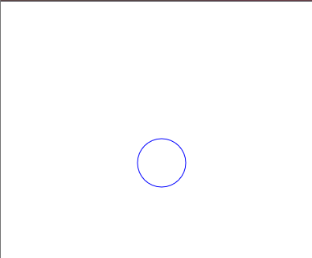

But now we need to be able to move out the circle around we need to go from left to right and up and down. Something to get moving and you may be wondering how do we do that well there’s actually particular method hat we need to go about to get the circle moving and this method is first creating a function and you can name this function anything you want we are going to call it animate because this function is going to be meant for animating and within this function we are going to be using another function called a requestAnimationFrame() this function take another function as an argument basically what’s going to happen is we are going to use this animate function by passing that to requestAnimationFrame as an argument (I think basically recursion is happening there and we pass animate function as a call back for requestAnimationFrame and when event happens associated with requestAnimationFrame then animate function is called and so on.)

2:05

Once we call this animate function this requestAnimationoFrame function is basically going to be creating a loop for us it’s going to say okay we want to be able to create loop basically and what function to call to loop though its going to say call this requestAnimationFrame and then call animate again then it’s goinv to call this requestanimationFrame(who knows) we are basically creating a loop it sycling through over and over again until we tell it to stop but his is only going to work if were actually call animate at the bottom of the screen if I save the file then I will not see anything because we don’t have actually any data or any input being put in the browser for it to be read(who knows)

So to put some data in there we are going to put a console statement within our animate function we are going to console “Hello”

And if we save the file and page get refreshed then you will see it is being called over and over again as shown below

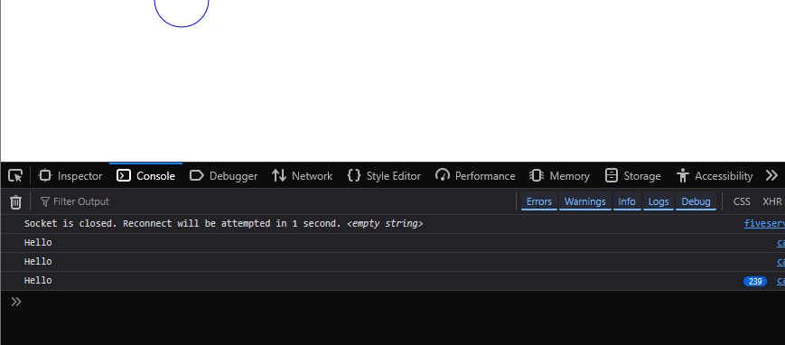

Our code will look like below

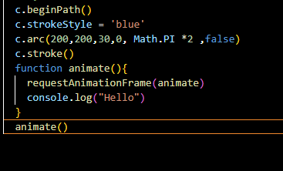

Iin console you can see Hello print is incrementing up and up. And it will keep going until it stop and there are certain ways to stop it. But for the purpose of this video lets just focus on the basics of getting our circle moving. So to get this thing moving its going to be good for you to understand how animation work in general

Animation works by refreshing the page we are basically going to be refreshing the page and each time we refresh the page we are going to be moving the circles x and y value incrementally very little so we are basically we are refreshing the page and then we are going to be incrementing our x value by one and as we increment it by one the circle is going to be move over to the right one by one. And we are just going to keep doing over and over again and its going to give us the illusion of animation   
It's going to be look like the circle is moving from its current location all the way to the right hand of the screen unless we tell it otherwise to do so or stop(not clear(who knows)) if we want to be incrementing our x values for our circles it really makes sense for use to grab our circle code and place it within your animate function so if we put this within our animate function and save the file and page is reloaded now the code will look like below

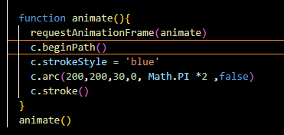

And our output will look like below

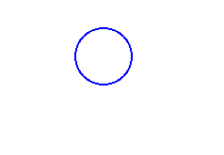

Now you can see that we are going to see that we have now have a bold circle that is because the circle is being drawn on top itself over and over again we only have x and y as 200 and 200 and since we are just drawing the circle on top itself but we want to make sure that we are changing these x and y values correspondingly so that they are not stuck at 200 we want to make sure that when the page refreshes itself then the c becomes 201 after refreshing and the 202, 203 and so forth and once we do that we are going to get the illusion of animation so whenever we want to change a number we need to create a variable and we are going to declare this outside our animate function. This is our global variable we assign it 200 so instead of using 200 within our x value for arc which we are going to be using our new x variable and then we are going to add one onto the current value of x each time the page is refreshed each time this animate function is called adding one onto x

Now our code will look like below

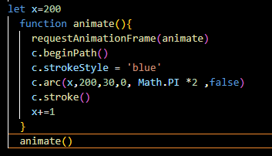

4:48

Now we save our file and page gets refreshed then you can see that output below

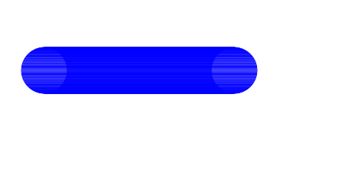

Now you can see our circles are moving from the left to right hand side of the screen but we are actually creating lots of circle in the process. And circular shapes are drawn on top of each other thus creating this line from left to right side of the browser screen Now to fix that basically what’s happening is that we are not actually clearing the canvas each time the page is refreshed each time our canvas is refreshing so we need to make sure that each time before we call arc we are clearing the canvas using clearRect() method and this is the same thing as fillRect method that we used up earlier It’s going op make an x value or y value and width and height so we are given to make sure we are clearing the entire canvas from 0, 0 to the canvas width and canvas height Now our code will look like below

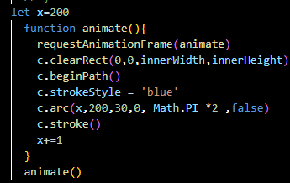

**Note:-**

The innerWidth actually means window.innerWidth as window is global

So this is going to clear canvas each time which give us an illusion such that when a next circle is drawn then previous circle will be removed Our output will look like below



Now you can see the circle Is not being drawn on top of each other over and over again we have this nice circle is being created for because we are clearing canvas each time this animate function is being called so its only getting us so far right now our circle is going off the screen and we don’t really want that there is no use of it going out of the screen because we can’t see it let’s go ahead and make it so that once hit side of the screen it bounces backward once it hit the left side of the screen it bounces backward as well it’s going to be bouncing left and right side of our screen in order to do it we need to make sure that we have conditional for our x velocity right now our x velocity is 1 and if you are unfamiliar with velocity then basically it is the speed or rate at which something moves in a particular direction so right now we are moving x coordinate at a speed of 1 pixel each time animate function is called and it is moving in a positive direction so therefore our velocity is 1 pixel per frame refresh to the right now since we want to make sure our velocity can be negative or positive we are going to want to create a variable for that as well so. Our variable is going to be called the dx and that just a standard acronym for our x velocity and this is going to be equal to 1 so instead of just adding 1 for x values we are going to adding dx instead as shown in our code

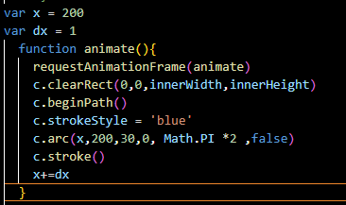

And play around with dx.

7:02

You can add 4 then it will now move very fast

We will keep it 1 but may change later once we can detect that right side of the browser(who knows)

So we know we have a velocity of 1 but we need a condition such that x equal to the innerwidth of the screen and go ahead and change our velocity to negative value so actually we are subtracting negative number from x we are actually subtracting the number which make the circle go to left hand side from right hand side to the left hand side

So we are going to say x > innerwidth of our browser screen then make the dx negative and assign it to itself so that it becomes negative when x value is greater than innerwidth

Lets see what will happen now

Now you will see that the ball is bouncing off the right hand side

Now our code will look like below

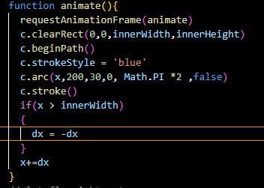

Now out output will look like below



So you can see that the circle is bouncing off right side of the browser window but if you see closely then you will see the edge is not bouncing outside of the screen Its actually the center of the circle we want to take into account we want to take into account our circle had a radius and that edge should be bouncing off screen and not the center of the circle

We need to say that is x plus circle radius and circle radius id equal to 30 but lets go ahead and create a variable for now so we again declare a global variable that is radius of 30

So we say id x value plus the circle radius is greater than innerWidth of our screen then go ahead and bounce it off now our code will look like below

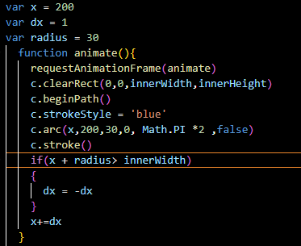

Now if we save this file and then in the browser after refresh you will see the output below



So now once the edge of the circle hits the screen we are now reversing the velocity so that the circle is going from right to left instead of left to right but one it hit zero you can see that it keeps on going past the width of the browser so we also need to take into account that conditional as well we can add an or operator in here and we can say if x – radius < 0 then reverse the velocity of our circle let see if that works out code looks like below

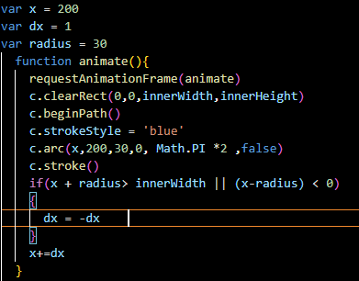

Our output will look like below



Now we have a circle that’s bouncing from the right and the left hand side of the screen.

9:20

We also want to make sure that this circle is bouncing of the top and bottom of the browser window screen so right now we make we have an x value which is bring varied up but we don’t have a y value which can be varied right now we have a value of 200 so we want to make sure we have a variable which we can set and change in the process so we declare a global variable that is y. we set its initial value to 200. We are going to need a y velocity so we are going to declare a global variable that is dy

We set dy equal to 4 and then now we have a variable for y coordinate and also our dy variable for velocity Now we need to make sure that we are adding our velocity onto our y coordinate. We are going to be adding dy to our y. we save the file and the page gets refreshed

Now our code will look like below

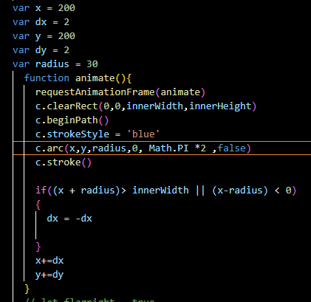

Now our output will look like below



We see that our circle moving diagonally but once it hit the bottom screen we are not actually bouncing anywhere we are going to make sure that once the circle plus its radius hit the bottom screen that it bounces up wars and then once its hits on the top screen then it bounces downward so we are going to do the same thing which we did for our x and innerwidth value so all we are going to add another conditional we are going to add another conditional we write if condition and then in condition we y + radius of the circle id grater then inner height and then we are going to reverse our y velocities. That is by dy = -dy

Now you will see that our ball bonces the bottom but not the top. So we add or operator and then add condition that is y -radius is less than 0 reverse the y velocity as well.

Now our code will look like below

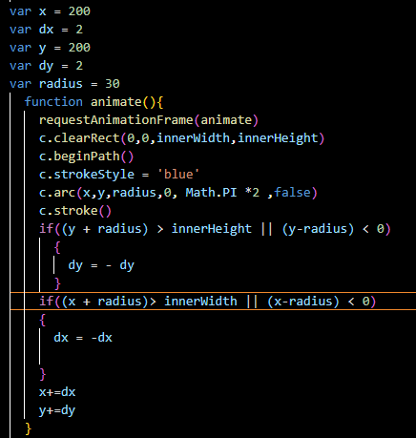

Now our output will look like below



Now you can see that circle is bouncing off the top, left , right and bottom of out screen so lets take one step further and randomize the velocity of our circle and we will also randomize the position so whenever our position so whenever out circle is spawn is going to be put in a random position in left and right hand side of the screen and it’s also going to be travelling in a different direction each time the circle is spawn.

11:17

So if you refresh the page then the circle start from a particular location we want that the circle should have a potential to spawned anywhere and go in any direction on the spawn currently out circle is moving in diagonal direction so there is a little bit of math involved with but nothing too hard let’s go ahead and get started with that So now our x and y value is set to be a hard coded value of 200 by 200 but this is not random at all we already know it is going to be generated at the position (200,200) so now we assign random values to x and y.

Now the value of x would lie between 0 and innerwidth and y should be 0 and innerHeight

So we assign x and y like below

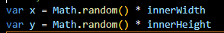

Now whenever you refresh your page then it will be generated random as shown below



But it does not actually give us a random velocity technically when a circle is spawn it’s going to be going from somewhere n to the bottom right direction we want o randomize our dx and dy so that dx can be negative or positive that way once the circle spawn if dx is negative then it ‘s going to left but if it is positive then it is going to right similar for dy if it is positive then circle will go downward and if dy is negative then circle will go upward

So to do this we apply below

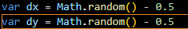

So we are going to using the math dot random this math.random will give random positive value rach time we get there 0 through 1 all we need to so is make sure we are getting a negative value so we subtract 0.5 from this and if you think about this that in Math.random the greatest

13:10

value you can get is 1. If we get one and subtract 0.5 then our greatest value id going to 0.5 but the lowest value id zero. So if we get 0 and subtract 0.5 we are going to get lowest value of negative 0.5 so that’s how this works ( but to make it speedy we subtract 1 from (Math.random() * 2)) either a positive or negative value just using this simple arithmatic function so we want to make sure that we are doing this for a y value as well and with this place you can see some randomized velocity by the code below

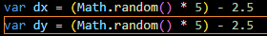

You can amp up your velovity by teacher method as shown below

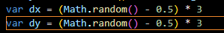

Now our circle will move slightly faster. Now we will see the sometimes ots fast and sometimes its is slow because we are getting random dx and dy value now

Now our output will look like below



if we want random speed between 4 to 8 well there are certain things we are going to do but for now lets just keep this simple

Know that this is how you get either a negative or positive value and you can map the speed of this by multiplying it by a factor that way you can get wither value from factor to -factor

Alright so we know how to animate a circle we know how to bounce it off edge of the scene

But some times we see that the circle is stuck on the edge of the scene and there’s a reason for that is because conditionals are interfering with spawn location of the circles and its harder to get randomize of the edge of the screen (who knows) so we are not going to worry about just yet what Teacher want to show us that is how to create multiple circles that have their own independent x and y values and independent velocity and independent radiuses and radii so that we can create multiple circles on the screen and have them all go in different directions

15:00

And we will see the, independent from each other So how do we go about doing that well is we want to create another circle here and have the same functionality we have been going on right now well there’s a quit a but that would go into that would need to create another arc function and we need to create whole lot of variable here. so that we can have a new math.random for x , y and new velocity and so forth we would also need to conclude conditional for all those new variables and it can get really tedious on the code and just not good price. Because we are duplicating our code we are also repeating ourself over and over again So to alleviate this we are going to be using object oriented js and we are going to start of by creating js object

We write function and name it circles and then curly brackets. That’s how you you create a javascript object (in older js(because lesson is 8 year old)) we keep the circle fists letter C to tell that it is a class

So we have a circle Class but this Circle class is going to need its independent x and y values. Each of our circles is going to be placed in the individual spot separate from one another so we need to make sure each circle has its own x and y value so to give each circle x and y value we are going to write inside circle class ( aka function) this.x = x and we are going to get x value well we are going to be passing it through our circle function (aka class) each time we instantiate a new circle(that is object).so each time we create a new circle(object) we are going to pass in an x argument now this x will be assigned to this.x(in another word instance variable of our object formed from our Circle class) and we are going to do same thing for y value. We want to make sure that our circle has its own independent y value we are going to say this.y = y

So we have a way to set x and y value for our own independent circle but we don’t have a way to draw these. These x an y values are worthless of they are not used anywhere so we want to make sure we are creating a method within our class Circle

And this method is going to be called draw. Now by using this property we are adding draw property to an anonymous function (function(){}) It does not have a name. So within anonymous function what’s going to happen is we are going to draw the circle whenever this is called

So lets instantiate a circle quick so we can get a better idea of how this is working. We are going to create a variable and this variable is going to be called circle this is going to be equal to a new circle with x value of 200 and y value of 200 as shown below



This is how you instantiate an object with js. You precede the function name with new and its going to store all the property and methods within the circle variable

So if we are going to fire whatever code is within synonyms function within this draw method of circle. Lets go ahead and add some dummy code here that is of console.log() we print hello Now we want to draw function well we would take our circle variable and we would call the draw method at the end as shown below



that’s all we really have to do. If we refresh then you are going to see that this function is being fired and you can see in consol that is Hello as shown below

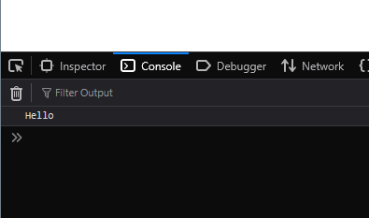

18:13

If we comment this circle.draw() then nothing will be shown in console ( later we uncomment it )so we want to make sure that whenever this is fired then make sure that by draw function we are drawing a circle ao we can go ahead and grab out draw circle as marked below in the code

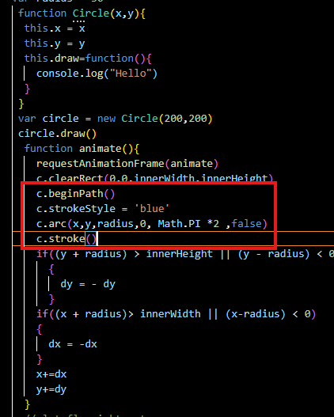

And paste it in the draw method and now if we save our file then after refresh it will look the same way it is because we still have out animate function running and our animate function is clearing the screen each time the frame is bring refreshed so the circle to draw is outside our animate function let’s go ahead and throw it in the animate function as marked below

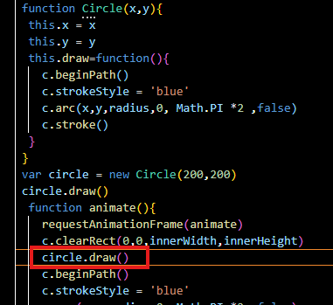

Now our output will look like below



So there’s our circle we created a circle and instantiated and start within a circle object and then we actually drew it on the screen with the help of draw method so right now this is a **static circle** as shown above

This is what we had earlier on previous lessons but we want to move to a point where it is bouncing off the screen moving like the other circle we created in animate function so how do we go about doing that well instead of just having one draw red function we are going to be including update function and this is going to be equal to anonymous function as well as marked below

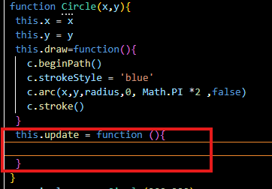

We are going to include the same code that we have in animate function as marked below

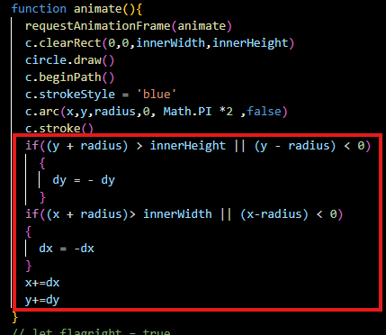

And this code is for velocity and all the conditionals to switch up the direction of our velocity so lets go ahead and take this out or comment as marked below

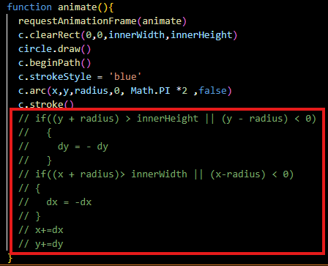

now you will see our circle is not going to animate any more as shown below

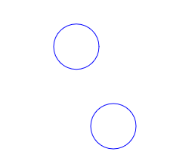

Lets put it within update method of circle class all we need to tweak few things here first we need to make sure that each individual circle has its own dx and dy velocity so we are going to say this.dx = dx and since we are bringing in a dx right here we need to make sure we are passing it through as an argument in Circle which means we also need a dy so we add it similarly as marked below

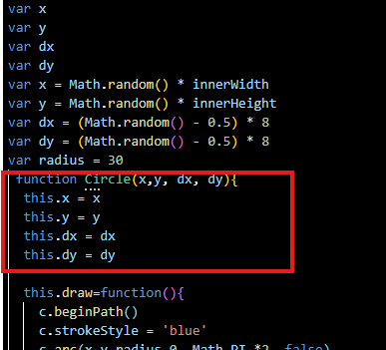

Now we have dx and dy velocity each individual circle is going to have it’s own independent from one another and now we just need reference to these within our update function

20:12

So right now they are referencing the random variables. We need to make sure they are referencing the circle properties so we need to prepend all our velocity and c and y by **this**.

Now our code will look like below

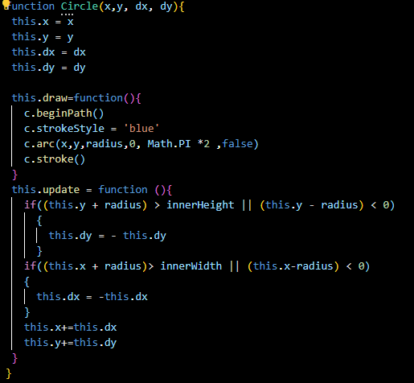

So right now our circle does not have its own radius independent from one another right now we are referencing the radius that is global and have a value of 30. So now we want to make sure our circle also have their own radius which can be referenced separately from one other circle so we declare another variable that is radius in circle and it will be equal to radius which will be passed to the circle class while making an object Now we are prepending our radius with this. That way are referencing this specific circles alright lets go ahead and fresh the page eight now we are still getting the randomizes circle but we are not seeing the circle we created by object because while making circle we are just passing values foe x and y but we need to set values for dx, dy and radius so we need to make sure we are filling each of these so we give dx to 3 and dy to 3 and then give radius of 30. As shown below



Now there are two circle that is being drawn that is shown below

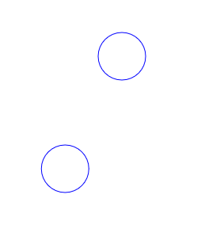

Its not moving as of yet that’s because we are not calling out update function we need to make sure that we are not just calling our draw function but we are also calling our update function Now we replace circle.draw with circle.update and if we refresh something now still nothing happens just the circle made by object is not being drawn as shown below

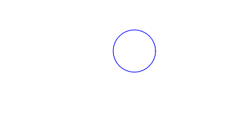

Because only our update function is being called instead of our draw function we want to make sure that we are first drawing out the circle and then we are changing all its properties. Once we draw the circle that’s when we can actually change properties hence we will move across screen in different directions so we can actually call this method within this update function so we put draw method inside the update method as shown below. Now our code will look like below

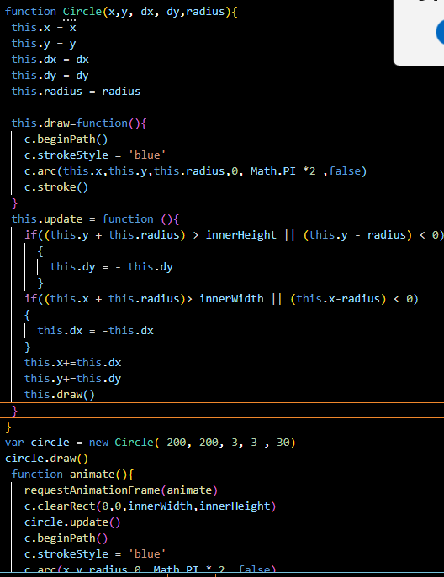

Now our output will look like below



Now you can see our circle made by object is moving thar’s updating and bouncing out the side of the screen independent from any other circle is being drawn so lets go ahead

23:13

And rid of this static circle. It kind of hardcoded circle that we created within the animate function

We comment the code marked below

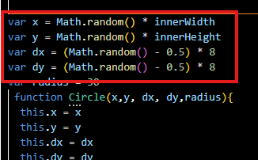

As we will use it when we want to randomize our values

Lets remove the code associated with the static circle as marked below

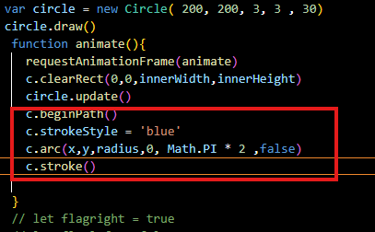

Now only one circle will be shown which is bouncing on the edges of the screen as shown below



And now since we have all randomization that we commented. Lets go ahead and integrate that into out code very quickly Now uncomment it and put it above the circle we created by initializing the object

So if we were to get this one circle randomized we put the randomized value in there respective position in the creation of circle object. But we want to be creating multiple circle on the screen so in the last lesson we covered the for loop and we know that for loop is meant to loop through something a certain amount of time that is prespecified amount of time so we are going to be creating for loop. Now our loop will loop like below

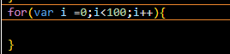

So we want to be creating hundred circles basically Now we copy our circle initialisation code and paste it in the for loop

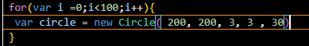

We want to make sure we are creating a 100 circle and store them within one variable and to store 100 circles within one variable. We are going to be creating an array called circleArray as shown below.

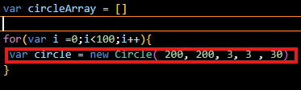

To create an array this is all you have to do just have to assign your variable to some bracket so this is going to store all the circle that we create .So to actually store a new circles that have independent values within this array 100 times. What we are going to do is we are going to create a new line withing our for loop and circle array is going to push a new circle each time this for loop is ran through so we get rid of code marked above. So we are going to make sure that all our values are randomized each time this for loop is ran so we grab all out variable declaration of x,y, dx and dy and put it inside the for loop so now we can use these values each time we instantiate a new circle so circle is going to have dome random x values , y values, dx and dy and it will have static hard coded radius at this moment so what’s happening is that we are creating 100 circle each with their own individual random x, y, dx and dy. Its going to be different each time because Math.random is going to produce different value each time this for loop is ran .Now our code look like below

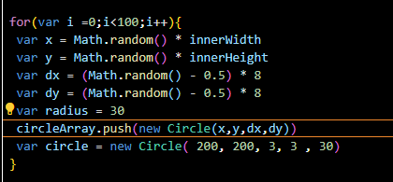

25:48

So now we have our circleArray and since we deleted our circle variable as shoen below in the loop

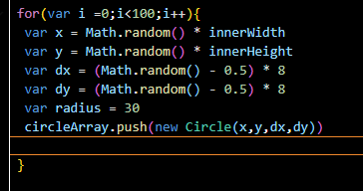

Lets go ahead and remove the circle.update from animate as shown below

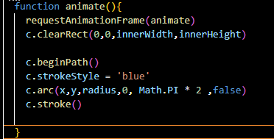

Now if we refresh our page we will not see anything on the output as shown below



It is because we are not actually drawing with the animate function but of we console log out circle array

As shown below

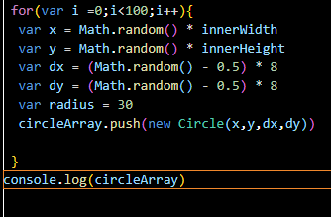

then we will see in console that there are 100 circle in our console as shown below

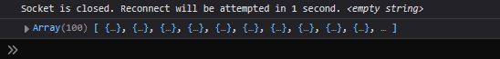

We can open these up and if we look at first circle you will see that dx and dy have very randomized value as marked below in console

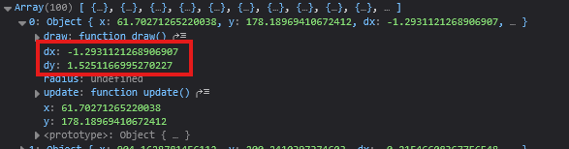

And if we look at second circle then you can see in console in marked below to see the dx and dx has different values

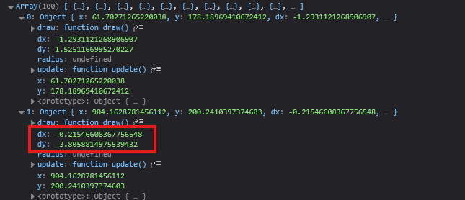

So all these circles have different value that are independent from one another which means they will spawn at different location and move in different direction but how do we actually get these drawn on the screen that is the next question we need to answer. So to get these drawn on the screen we are going to be creating another for loop but this for loop is going to be inside anim function

And we are going to start things off the exact same we did in previous loop technically we could say 100 here but usually it’s best practise declare how long your array is dynamically so basically we are going to use the length of the array for loop run and now if we add more circles into circleArray then it would automatically update loop run to something like 100 , 200 or whatever the length of the array is so we are basically increase the length of the array automatically by rather than hardcoding something like 100 so in the second section of for loop we are going to say circleArray.length for our upper limit of for loop as marked below

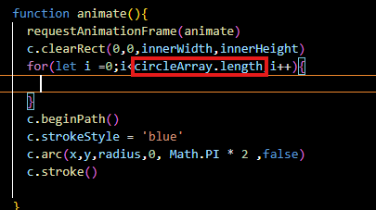

Now all it is saying that run it 100 times since length of out circle is a hundred that’s exactly we want because we want to be able to access all the individual item within our array and to access all the individual item within our array we need to first access our circle array and then access each individual index by using something like 0,1,2,3,4 and 5 so forth but instead of typing manually we are just going throw our i variable

27:38

Since our for loop is running repetitively over and over again it’s going to be accessing all of our circles within the array automatically and since it’s doing so basically what’s happening is that the first time loop is called we are accessing our first circle and out first circle has an update function so we are going to call update on it and then automatically it’s going to go to the next circle and call update of it as marked below and then it’s going to do that until it reaches the very end of all our circles Now our code will look like below

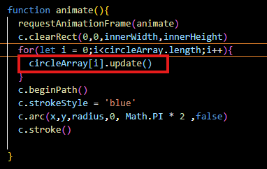

Now if we save our file then our output will be like below



Now you can see we have circles being spawned on different location bring moved in different al over the direction It was very fast so Teacher make it very small. So right now our circles are being spawned to the point where there are radii(means some part of some circles) are getting are getting caught in the left and right hand side of the screen and same thig for a top and bottom.

As shown below

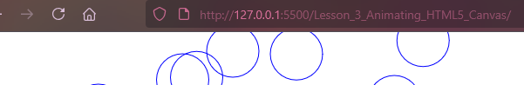

We want to make sure this is not happening we all make sure our circles are only being spawned within the canvas coordinates o to make siure this happening (see it later)

28:38

WE now make the x and y as marked below

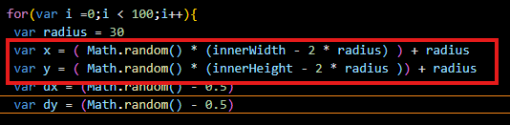

And now you can se the output that no circle is now being cut down by the screen edge (we also decrease the circle speed)as shown below

**Output:-**



Now you can see our all the circles are being spawned randomly and random velocity and all inside the canvas coordinates so that’s a lot to cover we just cover object oriented programming, animation ,the velocity , x values some math of math.random getting these to spawn in different coordinates making sure they are not spawning out of the screen we also cover conditionals a lot to cover in one episodes So don’t you feel that if you are not getting everything right away guys but really focus on the main subjects that we covered Teacher want us to take it really easy experiment with all these change in color of these you can get dome really coo effects going on just by changing colors the velocity and so forth lets go ahead and change the color of our circle within out draw method and give it a fill as marked below

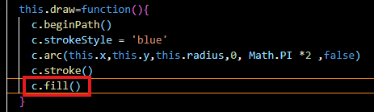

Now our output will look like below



You see that we already get cool effect going on with our black background on our blue border in the circles go ahead and play around it’s a lot use square line and so forth anything you like to use see what kind of stuff we can come up with. Now in next lesson we are going to learn how to interact with it based on event listener with mouse events and also touch movement in your phone